Laparoscope Drawing Pack
 | Student | Supervisor
Initials and Surname | PW Breytenbach | Prof K. Schreve
Email Address | 26122146@sun.ac.za | kschreve@sun.ac.za
Contact Number | 078 780 9388
Signature | 

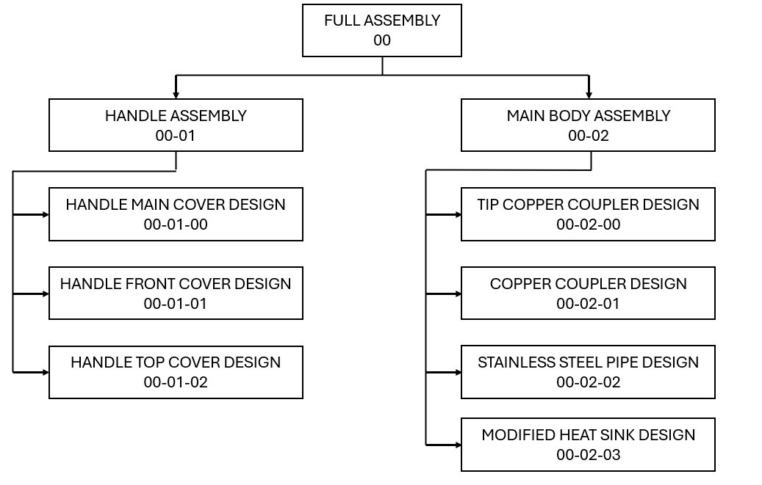

Notes for the assembly:
Parts that interface with each other that are not connected by a bolt and nut connection are secured by epoxy. Thus, all parts that interface with the heat pipes and stainless steel pipe will be secured by epoxy. The entire assembly of the design will be performed by the student, including the application of epoxy.
Order of assembling the handle of the laparoscope:
- Assemble the entire main body assembly, except for the heat sinks.
- Insert and secure the heat pipe and stainless steel pipe into the “Handle Front Cover”.
- Connect the heat pipe to the heat sinks.
- Connect the “Handle Front Cover” to the “Handle Main Cover”.
- Connect the heat sinks to the “Handle Main Cover”.
- Connect the “Handle Top Covers” to the “Handle Main Cover”.

